

__________________________________________________________

**RHODES UNIVERSITY SUSTAINABLE LAND MANAGEMENT FOR RURAL RESILIENCE PROJECT (RU-SLMRR), GEF5**

**QUARTERLY PROGRESS REPORT**

______________________________________________________________

**Report compiled by**: Dugal Harris

**Organization**:

**Quarter and year**: 012018

**Reporting outputs**: 3.1b

**Date of report:** 14032018

__________________________________________________________________________________

# INSTRUCTIONS

# Please refer to Sections A-E below and include the necessary information and attachments to document your progress toward one or more outputs of the GEF5 SLMRR Project (use the examples provided to guide you).

# Please submit your completed progress report on or before the 12th day of the final month of a particular quarter. This is according to reporting regulations set by Department of Environmental Affairs for the GEF5 SLM Project.

# Please submit your report to: Rebecca Powell (rebeccajoub@gmail.com) and cc James Gambiza (j.gambiza@ru.ac.za).

# SECTION A: OUTPUTS PROGRESS & CHALLENGES (Please complete columns A-F in the table below)

**\***Progress toward achieving planned activities indicated in column C.

**\*\*** Challenges to achieving progress on activities, as identified in columns C and D

| AOutput code | BYR1 goals (deliverables) | CPlanned activities for reporting quarter | DProgress*1 = completed, no concerns; 0.5 = partial progress, some concerns; 0 = no progress, major concerns | EChallenges** | FAddressing challenges |
| --- | --- | --- | --- | --- | --- |
| 3.1b | Report on the development of a new carbon methodology for Spekboomveld rehabilitation projects and applicability to these kinds of projects | 1) Generate field sampling plot locations for Sewefontein farm.2) Apply differential correction to field DGPS data acquired to date.3) Process field allometric data to produce woody carbon stock (CS) estimates.4) Perform data analyses to check validity of CS sampling methodology (i.e. plot quantity and positioning) using NGI aerial imagery.5) Preliminary correlation analysis of woody CS and image features.6) Literature survey and comparison study on feature selection methods. | 1) 12) 13) 0.54) 15) 16) 1 | 3) Allometric models do not exist for all species.4) There is currently no model to relate image features to woody CS.5) Satellite image has not been acquired yet and only 18 plots have been sampled to date. | 3) Where possible, species without models were grouped into guilds with known species. For some species there are no obvious guilds. These cases require further consideration – it may be necessary to develop new allometric models which could be done using data from Mike Powell’s MSc.4) NDVI was used as a coarse proxy for woody CS.5) A comprehensive analysis will be conducted in Q3&4 once all plots have been sampled and a Worldview-3 image has been acquired. |

# SECTION B: IDENTIFIED RISKS AND SOLUTIONS

# Describe the identified risks to the project outputs

# *There are currently no risks to completing the carbon stock mapping study in 2018. The majority of this work can however only be done once the carbon stock field sampling has been completed at the end of Q2. The complete field sampling data set is required to build the model that relates carbon stocks to image measurements. A minor adjustment to the 2018 budget is therefore requested i.e. a 1 day/week decrease in Q2 expenditure and a corresponding increase in Q4 expenditure (see attached document: “OUTCOME 3_2018 - DH rev1.xlsx”).*

# Describe possible solutions to identified risks

# SECTION C: SUMMARY OF LESSONS LEARNT DURING THE REPORTING QUARTER

# *An analysis of the variation in NDVI with distance does not justify the use of a clustered plot design.*

# *An analysis of the spread of NDVI values indicates that an equal split of plots between the degradation strata should produce a reasonably uniform spread of woody CS estimates.*

# *DGPS locations acquired in the GEF study site can be corrected to <50cm accuracy.*

# *Feature selection methods appropriate for regression analysis have been identified.*

# SECTION D: BUDGET TRACKING

# Please note that you will be required to submit a financial report at the end of 2017 (Before December) detailing your expenditure for the year. This requires that you keep a record of all invoices and receipts relating to project expenditure. The format for the report will be sent closer to the time.

**SECTION E: APPENDICES**

**APPENDIX 1:**

*An investigation of the suitability of a clustered plot layout was conducted by analysing how NDVI changes with increased distance between plots. A clustered plot layout is one where plots are grouped in closely spaced clusters to help save travel time between plots.* Figure *1 shows NDVI variograms for each degradation stratum (the median change in NDVI is shown in red, while the black points represent the change for each possible pairing of a plots). It is apparent that the NDVI variation increases with distance for all degradation strata. This does not seem to support the use of the clustered plot design as representivity of larger NDVI variations would be decreased by biasing the data set towards closely spaced plots.*

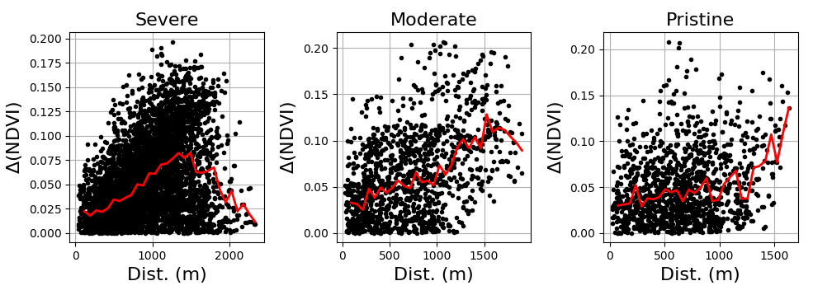

Figure 1 NDVI variograms for each degradation stratum (“severe”, “moderate” and “pristine”)

**APPENDIX 2:**

*The distribution (probability density) of NDVI values over the sampling plots for each degradation stratum was calculated using kernel density estimates (KDE’s). This analysis gives a rough indication of what CS spread can be expected from the current sampling plot layout, where NDVI serves as a proxy for woody CS. NDVI was extracted from rectified and radiometrically calibrated NGI aerial images for each sampling plot. The NDVI distributions for each degradation stratum are shown in* Figure 2*. As is expected, the range of NDVI values increases as the degradation strata proceed from “severe” to “pristine”. The bottom right plot shows the distribution for the combined plots with 30, 20 and 40 plots from the “severe”, “moderate” and “pristine” strata respectively. There is a fairly uniform spread of NDVI for the combined plots which is desirable from a regression analysis and representivity perspective.*

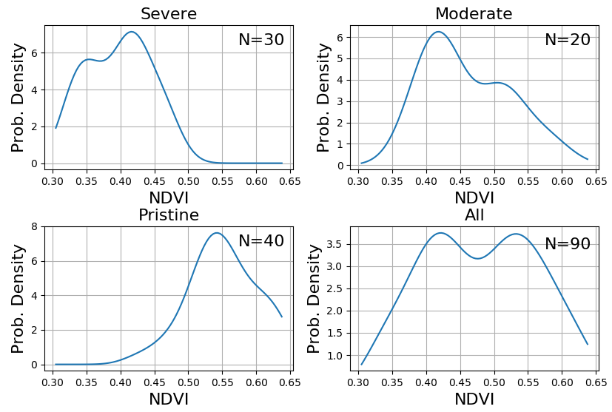

Figure 2 NDVI distributions for each degradation stratum (“severe”, “moderate” and “pristine”, and the combination thereof)

**APPENDIX 3:**

*Using corrected DGPS data and NGI aerial imagery, NDVI and various other image features were calculated for the 18 field plots sampled to date.* Figure *3 shows the correlation between log(NDVI) and allometric woody CS estimates. This initial result shows moderate correlation between these variables. While somewhat encouraging, this analysis should be not taken as indicative of what will be achieved with a more comprehensive model built on the full CS data set with a Worldview-3 satellite image.*

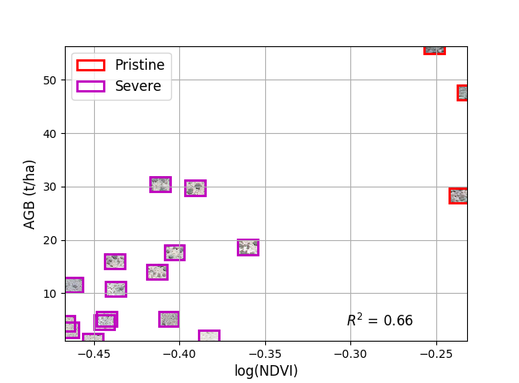

Figure 3 Woody CS (“AGB”) and log(NDVI) scatter plot

**APPENDIX 4**

*A paper describing a feature selection method is attached to this document (see “Feature Clustering and Ranking - GEF.docx”). Some of the reviewed feature selection methods detailed in the introduction will be of use for the development of the carbon stock mapping technique.*